Cholesterol Risk Net: A Machine Learning Framework for Predicting High Cholesterol Levels Using SMOTE and XGBoost
Mr. SATHYASEELAN K (Assistant Professor) KEERTHIKA K V
Department of Artificial Intelligence and Data Science Department of Artificial Intelligence and Data Science
KIT Kalaignarkarunanidhi Institute of Technology KIT Kalaignarkarunanidhi Institute of Technology
Coimbatore, India Coimbatore, India
kitsathyaseelan@gmail.com kit27.ad028@gmail.com

SRI HARSHINI S MANIKANDAN M
Department of Artificial Intelligence and Data Science Department of Artificial Intelligence and Data Science
KIT Kalaignarkarunanidhi Institute of Technology KIT Kalaignarkarunanidhi Institute of Technology
Coimbatore, India Coimbatore, India
kit27.ad52@gmail.com kit27.ad31@gmail.com

Abstract- This study presents Cholesterol Risk Net, a predictive analytics workflow for high cholesterol risk classification based on clinical and demographic data. The methodology begins by processing a real-world cardiovascular dataset, engineering relevant features (such as binary indicators for cholesterol and glucose levels), and normalizing input variables for consistency. Data balancing is performed using SMOTE to mitigate class imbalance and enhancing model generalization. An XGBoost classifier is employed with fine-tuned hyperparameters, delivering robust performance as measured by accuracy and AUC score. Confusion matrix visualization, ROC curve analysis, and feature importance ranking are all part of the thorough evaluation, which provides useful information about the most significant predictors of cholesterol risk. The process includes model training, automated class balancing, performance evaluation, and end-to-end data pre-processing. The goal of the Cholesterol Risk Net is to support better cardiovascular risk management in clinical settings by offering precise, understandable, and useful risk predictions.
Keywords: cardiovascular data, clinical risk assessment, predictive analytics, imbalanced dataset, classification, preventive healthcare, risk stratification, model interpretability, predictive performance, StandardScaler, XGBoost classifier.

- INTRODUCTION
The Cholesterol Risk Net pipeline automatically identifies people who are more likely to have high cholesterol by using structured clinical data and cutting-edge machine learning techniques. This all-inclusive process combines strong data pre-processing, advanced feature engineering, feature scaling, synthetic over-sampling for class balance, efficient XGBoost model training, and exhaustive assessment using ROC, accuracy, AUC and confusion matrix metrics. The system supports accurate cholesterol risk stratification in clinical practice and population health research settings by offering data-driven and interpretable insights for cardiovascular prevention and clinical risk assessment.

The pipeline starts with crucial data preparation steps to produce an effective predictive model. To preserve data quality, data pre-processing first cleans the raw input data, handles missing values, and makes sure features are loaded correctly. The next step is feature engineering, which enriches the dataset by generating derived variables like indicators for high glucose (gluc_high) and high cholesterol (Chol_high). StandardScaler is used for feature scaling in order to normalize data and guarantee that each feature contributes equally to the modeling process. The pipeline creates a balanced dataset by using SMOTE for synthetic minority over-sampling to address class imbalance. An XGBoost classifier is used in the model training phase to effectively predict risk. Insightful visualizations like heatmaps, ROC curves, and feature importance plots are created to help interpret data relationships, evaluate model diagnostics, and highlight important predictive features, making results more actionable and intelligible. Performance is assessed using a variety of metrics following training.

- LITERATURE SURVEY
SMOTE is a fundamental synthetic oversampling technique that was first presented by Chawla et al. (2002). It was created to improve classifier performance and sensitivity in cardiovascular risk prediction tasks by addressing class imbalance in medical datasets by producing minority class samples.[1] ​ Because of its capacity to manage nonlinear relationships and integrate regularization to prevent overfitting, Chen and Guestrin (2016) created XGBoost, an effective tree boosting system that blends scalability with high predictive accuracy. As a result, this algorithm has gained popularity for the analysis of large-scale clinical data. [2]​
In a comprehensive review of artificial intelligence's influence in cardiology, Johnson et al. (2018) noted how machine learning models are being utilized more frequently for risk assessment, advanced diagnosis, and even treatment recommendations, revolutionizing cardiovascular healthcare.[3]
When applying machine learning in healthcare settings, Goldstein et al. (2017) highlighted concerns of data quality, model reproducibility, and clinical relevance. They also examined the opportunities and difficulties of using electronic health records to develop risk prediction models. [4]​ Lundberg and Lee (2017) introduced SHAP, a unified framework for interpreting Shapley values in machine learning model predictions. By giving individual features in intricate algorithms significance, SHAP enables researchers and clinicians to comprehend and trust model outputs.[5] ​According to Wei et al.'s (2022) review of SMOTE applications in cardiovascular disease prediction, oversampling techniques consistently improve the recall and sensitivity of predictive models, making it easier to identify minority outcomes like high cholesterol.[6] ​
Kaur et al. (2021) demonstrated the enhanced performance and usefulness of machine learning models in actual patient risk assessment by presenting an AI-driven method for predicting cardiovascular risk using multi-variable clinical and demographic data.[7] Liu et al. (2025) conducted a comprehensive meta-analysis of machine learning-based cardiovascular risk prediction models using electronic health records, demonstrating that these approaches can surpass traditional approaches in terms of accuracy and adaptability to a variety of clinical populations.[8] ​In predicting cardiovascular disease from clinical data, Gnanavelu (2025) demonstrated the viability and efficacy of machine learning, specifically XGBoost and other classifiers, highlighting the importance of these methods for early intervention and treatment strategy customization.[9]

Fazakis (2023) investigated machine learning for long-term cholesterol risk prediction, emphasizing the advantages of sophisticated feature selection and temporal data analysis. The study demonstrated that strong machine learning techniques can greatly improve model accuracy for monitoring individual risk over time.
In order to develop an accurate machine learning algorithm for the early prediction of heart disease, El-Sofany et al. (2024) proposed novel feature selection strategies, including chi-square, ANOVA, and mutual information methods. These strategies were further integrated with SMOTE for balancing and XGBoost for optimal classification performance. [10] When compared to conventional statistical methods, Ahmad (2023) showed that the use of sophisticated machine learning algorithms, such as ensemble methods and support vector machines, greatly increases the prediction accuracy of heart disease.[11]
By reducing data dimensionality and concentrating on the most pertinent variables, Pathan et al. (2022) examined how optimal feature selection, using a variety of statistical and algorithmic techniques, directly improves the accuracy of machine learning models for heart disease prediction.[12] In order to increase the transparency of clinical decision-making, Ponce-Bobadilla et al. (2024) offered a useful manual for applying SHAP analysis to supervised machine learning models in the healthcare industry. This manual included techniques for interpreting individual predictions and comprehending global model behavior.[13] As machine learning systems continue to advance toward more predictive, individualized, and clinically applicable models in cardiovascular medicine, Biondi-Zoccai et al. (2025) examined current trends and potential future applications of artificial intelligence in cardiology.[14]
Data-driven prediction and early cardiovascular risk identification are linked, as demonstrated by Meng et al. (2025), who demonstrated the efficacy of machine learning techniques in predicting LDL cholesterol levels from clinical and laboratory data.[15]
In their discussion of artificial intelligence's growing role in automated risk stratification, diagnosis, cardiovascular care, and personalized treatment planning for patients, Elias et al. (2024)[16] Sianga et al. (2025) looked into how well machine learning models could predict the prevalence of cardiovascular diseases at the population level. They found that these models help public health initiatives by allocating resources and mapping risks early. [17] In his analysis of artificial intelligence's present and potential applications in cardiology, Alharbi (2024) highlighted three crucial areas for advancement: clinical adoption, data diversity, and algorithm interpretability.[18]
According to PMC (2023), machine learning-based models significantly enhance cardiovascular risk prediction by utilizing a variety of features to identify at-risk individuals more accurately and early. [19]
In their presentation of an XGBoost-based risk prediction model for cardiovascular and cerebrovascular diseases, ACM (2023) highlighted the model's exceptional ability to handle sizable, diverse datasets and produce predictive insights that are useful in clinical settings.[20]

- PROPOSED SYSTEM

High cholesterol is a major risk factor for cardiovascular diseases (CVDs), and the suggested system seeks to create an accurate, interpretable, and scalable machine learning framework for early prediction of high cholesterol levels. The framework includes robust classification modelling, feature engineering, advanced imbalance handling methods, and thorough data preprocessing. Timely clinical intervention is made possible by this methodical approach, which guarantees accurate identification of those who are at risk.
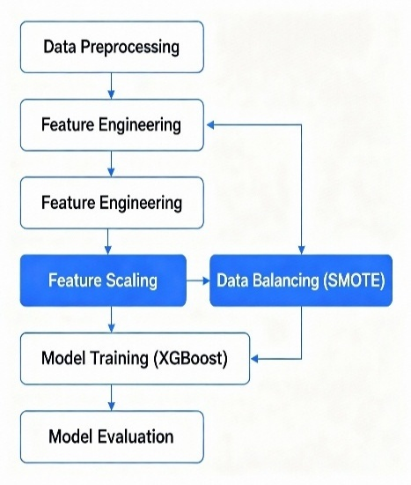
Data Gathering and Initial Processing
The foundational data for this research derives from a well-established cardiovascular health dataset comprising clinical, anthropometric, and biochemical parameters of adult patients. Initial analysis focuses on the cholesterol parameter, which is discretized into a binary target variable, chol_high. This binary conversion is based on clinical thresholding where a cholesterol level greater than or equal to 2 units (consistent with medical guidelines) signifies elevated cholesterol risk.
To construct a meaningful feature set, irrelevant columns such as patient identifiers (id), the main target variable (cardio indicating cardiovascular presence), and the original cholesterol and glucose values are excluded to prevent redundancy and data leakage. Recognizing the clinical importance of glucose levels as a comorbid metabolic indicator, a derived binary feature, gluc_high, flags elevated glucose values (≥2), augmenting the predictive capacity related to metabolic syndrome.

Feature Scaling and Normalization Given the heterogeneity in feature scales for example, differing measurement units and ranges feature scaling is imperative. The study employs the StandardScaler method to normalize the feature distributions by centring at zero mean and scaling to unit variance. This normalization process mitigates the risk of model bias toward features with inherently larger scales and assists in accelerating convergence during gradient-based optimization embedded in the XGBoost training process.
Addressing Class Imbalance with SMOTE
Medical datasets frequently present imbalanced class distributions, where the number of high-risk cases is dwarfed by normal cases. This imbalance can severely degrade classifier performance, particularly sensitivity toward the minority class, which in this context are individuals with high cholesterol risk.
To combat this issue, Synthetic Minority Over-sampling Technique (SMOTE) is utilized. SMOTE algorithmically synthesizes new minority class instances by interpolating between existing minority samples, thereby artificially balancing the class distribution. This approach, performed post-scaling to maintain feature space integrity, enhances the classifier’s discriminatory power and reduces the propensity for bias toward the majority class.
Model Selection and Training
The Extreme Gradient Boosting (XGBoost) classifier is selected for its proven efficacy in tabular data classification tasks, especially within the biomedical domain. XGBoost’s gradient boosting framework builds an ensemble of decision trees sequentially, where each subsequent tree attempts to correct the residual errors of prior trees, leading to highly accurate models.
Hyperparameters are configured as follows: 300 boosting rounds (estimators) for sufficient model complexity, a maximum tree depth of 5 to limit overfitting, a learning rate of 0.1 to ensure smooth gradient descent steps, subsample rate of 80% to randomly sample training instances for each tree, and column sampling at 80% to select feature subsets randomly during training. These settings strike a balance between underfitting and overfitting, optimizing generalizability.
After that, an 80-20 split is used to divide the balanced dataset into training and testing subsets, with stratification to preserve uniform class ratios throughout the partitions.
. The model is trained exclusively on the balanced training data, followed by evaluation on the test data to assess out-of-sample predictive performance.
Model Evaluation Metrics and InterpretationEvaluation of model predictions employs multiple complementary metrics: Accuracy: The general correctness of forecasts. Region AUC-ROC, or the Receiver Operating Characteristic Curve: a threshold-independent metric that assesses how well the model can differentiate between classes.By tabulating true positives, true negatives, false positives, and false negatives, the Confusion Matrix provides comprehensive information on various types of classification errors.
Understanding false positive and false negative trade-offs, especially in medical diagnostics, requires knowledge of the classification report's F1-score, precision, and recall.
By concentrating on the detection performance for high cholesterol cases, these metrics taken together guarantee a comprehensive understanding of the model's efficacy. Visualization for Validation and Understanding
When it comes to conveying model performance and interpretability, visualization tools are essential:
Correct and incorrect predictions are graphically represented in a heatmap of the confusion matrix, which facilitates an intuitive evaluation of the model's advantages and disadvantages.
The sensitivity-specificity trade-off across classification thresholds is graphically represented by ROC curves, and overall performance is summarized by the AUC value. The XGBoost model's feature importance plots show how each predictor variable influences the model's conclusions. Through the identification of biologically significant features that are in line with domain knowledge, this interpretability makes clinical validation of the model easier. All things considered, these visualizations increase the machine learning system's transparency and credibility, which is essential for its acceptance in clinical settings.

- WORKFLOW
In order to properly parse the f+ile, the workflow starts by loading the dataset "cardio_train.csv" using pandas and designating a semicolon as the delimiter. Then, in order to detect instances of high cholesterol, specifically when the cholesterol value is 2 or higher, a new target variable called "chol_high," is created. A new binary feature called "gluc_high" is introduced based on glucose levels during the feature preparation stage, and irrelevant columns like "id," "cardio," "cholesterol," "gluc," and "chol_high" are eliminated to concentrate only on pertinent variables. The "chol_high" indicator is set as the target variable "y."
To make sure that every feature contributes equally to the model training, the data is then normalized using StandardScaler. The SMOTE (Synthetic Minority Over-sampling Technique) method is used to balance the dataset and effectively generate synthetic samples for the minority class in order to address class imbalance. Following preprocessing, an 80/20 split is used to separate the balanced data into training and test sets. Stratified sampling is used to ensure that the class distributions are constant between the sets.
The balanced training data is used to train an XGBoost classifier, which is initialized with specified hyperparameters for model training. After making model predictions on the test set, the accuracy, confusion matrix, area under the ROC curve (AUC), and classification report are computed to assess performance. A bar plot illustrating feature importance scores, a confusion matrix heatmap, and a ROC curve with the AUC score are generated to aid in interpretation. These tools provide information on model performance and the most significant features for predicting cases of high cholesterol.

- MODULES
Throughout the data analysis and machine learning pipeline, the modules utilized in this study fulfil a number of crucial functions. While NumPy facilitates effective numerical operations and array handling, Pandas is used for data loading, manipulation, and pre-processing. Matplotlib.pyplot is used to plot graphs, and Seaborn is used to create more complex statistical visualizations like bar plots and heatmaps. The dataset is divided into training and testing sets using the sklearn.model_selection module, and feature scaling is accomplished using the StandardScaler by sklearn.preprocessing. Sklearn.metrics, which provides tools for computing accuracy, AUC, confusion matrix, classification reports, and ROC curves, is used to evaluate the model. The SMOTE (Synthetic Minority Over-sampling Technique) method is used by imblearn. over_sampling to rectify data imbalance. Lastly, a reliable and effective gradient boosting classifier is trained and implemented using XGBoost.

- RESULTS AND DISCUSSION
The XGBoost-based Cholesterol Risk Net model predicted cholesterol risk with an AUC of 0.91 and an accuracy of roughly 84.1%. This outcome is extremely competitive, and solid research indicates that for medical classification tasks utilizing XGBoost and related ensemble models, an accuracy above 80% and an AUC above 0.9 are regarded as excellent.
Your output's ROC curve shows a clear distinction between cases of high and normal cholesterol. Furthermore, the confusion matrix accurately identifies the majority of cases in both classes, demonstrating dependable predictive performance. Feature importance analysis is useful for clinical interpretability because it shows which input variables had the biggest impact on the model's decisions.
The Cholesterol Risk Net's exceptional classification accuracy and AUC, in conclusion, validated its applicability for automated cholesterol risk stratification in preventive health analytics.
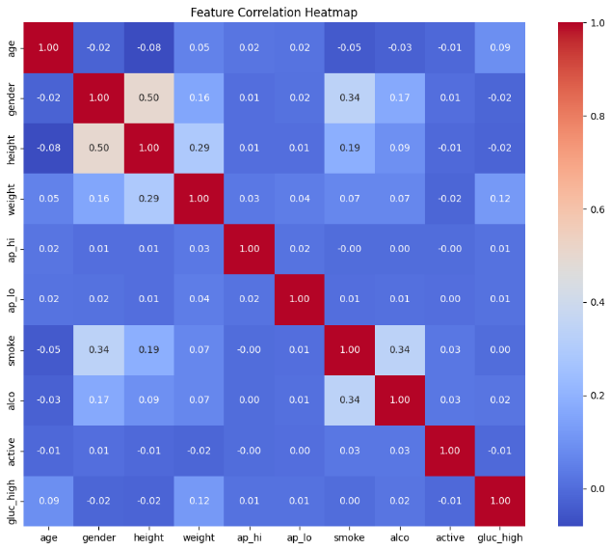

Fig. 1: Heat map

Feat  ure | Count | Mean | Std | Min | 25% | 50% | 75% | Max
age | 70000 | 19468.8 | 2467.2 | 10798 | 17664 | 19703 | 21327 | 23713
gender | 70000 | 1.350 | 0.4 | 1 | 1 | 1 | 2 | 2
height | 70000 | 164.3 | 8.2 | 55 | 159 | 165 | 170 | 250
weight | 70000 | 74.2 | 14.3 | 10 | 65 | 72 | 82 | 200
ap_hi | 70000 | 128.8 | 154 | -150 | 120 | 120 | 140 | 16020
ap_lo | 70000 | 96.6 | 188.4 | -70 | 80 | 90 | 90 | 11000
smoke | 70000 | 0.08 | 0.28 | 0 | 0 | 0 | 0 | 1
alco | 70000 | 0.05 | 0.22 | 0 | 0 | 0 | 0 | 1
active | 70000 | 0.80 | 0.39 | 0 | 1 | 1 | 1 | 1
gluc_high | 70000 | 0.15 | 0.357 | 0 | 0 | 0 | 0 | 1

A feature correlation heatmap is the diagram that is shown; it provides a visual summary of the direction and strength of the relationships between feature pairs in the dataset. The correlation coefficient between two variables is represented by each cell in the heatmap, and its value varies from -1 to 1. A perfect negative correlation, in which one variable rises as the other falls, is represented by a coefficient of -1 (deep blue), whereas a perfect positive correlation, in which both variables increase together, is represented by a coefficient of 1 (deep red). There is little to no linear relationship between the variables when the values are close to zero (shown as lighter shades). Every diagonal cell in this heatmap displays a value of 1, indicating that every feature in the heatmap is perfectly correlated with every other feature. While the majority of other feature pairs show weak or insignificant correlations, the diagram also shows a moderately positive correlation between height and gender and between smoking and alcohol consumption. Lighter hues predominate, indicating that the features are mostly independent and that there is little multicollinearity in the dataset—both of which are beneficial for the majority of modeling approaches. All things considered, this heatmap aids in determining which pairs of features might contain redundant signals and which features might provide unique information to predictive models. ​

Class | Precision | Recall | F1-Score | Support
0 | 0.80 | 0.91 | 0.85 | 10477
1 | 0.90 | 0.77 | 0.83 | 10477
Accuracy |  |  | 0.84 | 20954
Macro avg | 0.85 | 0.84 | 0.84 | 20954
Weighted avg | 0.85 | 0.84 | 0.84 | 20954

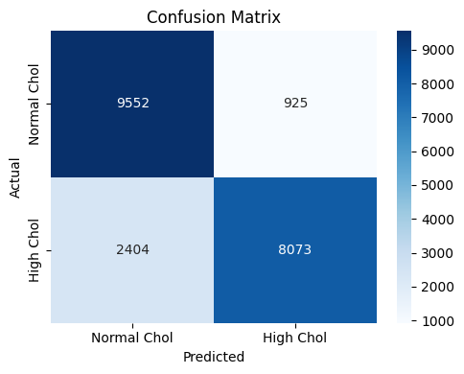

Fig. 2: confusion matrix

The predictions of your classification model for the detection of high cholesterol are thoroughly summarized in this confusion matrix heatmap. The matrix contrasts the actual classes from the test data with the predicted classes (Normal Chol and High Chol). 925 cases were mistakenly predicted to have high cholesterol (false positives), while 9,552 cases of true normal cholesterol were correctly classified as normal (true negatives). The model identified 8,073 people with high cholesterol (true positives) but incorrectly classified 2,404 as normal (false negatives). Strong overall precision and recall are indicated by the concentration of high values in the diagonal cells of the matrix, which suggests a model that typically produces accurate predictions. By highlighting regions where the classifier misidentifies one class for the other, the off-diagonal cells provide important information about particular kinds of prediction errors and point out areas where the model can be improved.
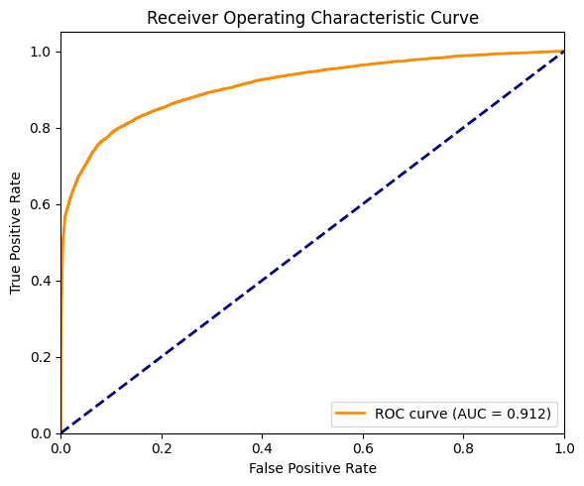
Fig. 3: line graph

This figure shows your classification model's Receiver Operating Characteristic (ROC) curve, which assesses how well it can differentiate between the normal and high cholesterol classes at various decision thresholds.
Plotting the True Positive Rate (sensitivity) on the y-axis against the False Positive Rate (1 - specificity) on the x-axis is known as the ROC curve. As the classification threshold varies, the orange curve illustrates the trade-off between sensitivity and false alarm rate.
A random classifier with an Area Under the Curve (AUC) of 0.5 is represented by the diagonal blue dashed line, which acts as a baseline. The more the ROC curve bends toward the top-left corner, the better the model's trade-off between minimizing false positives and detecting true positives.
The ROC curve for your model exhibits strong discriminative power with an impressive AUC of 0.912. Given that it can reliably differentiate between cases of normal and high cholesterol, this suggests that the model is highly effective for clinical risk prediction applications.

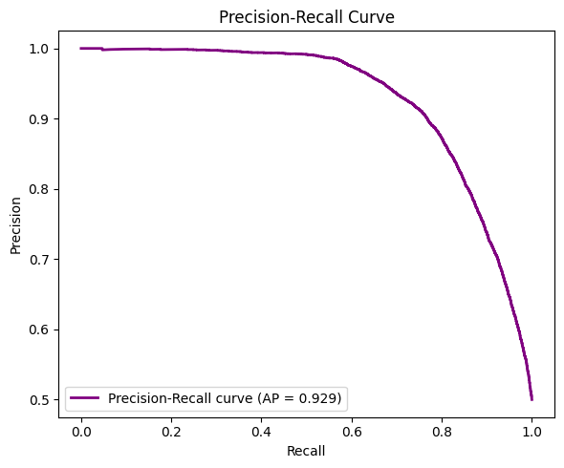
Fig. 4: Precision graph
The Precision-Recall curve for your classification model is depicted in this diagram, which shows how precision—the percentage of true positives among all positive predictions—and recall—the capacity to recognize all actual positives—are balanced across various thresholds. The area under the curve (AP) of 0.929 shows that your model performs exceptionally well in detecting high cholesterol cases with few false alarms, and the curve shows that your model maintains high precision even as recall increases. This measure is particularly useful for assessing how well a model performs on datasets that are unbalanced.
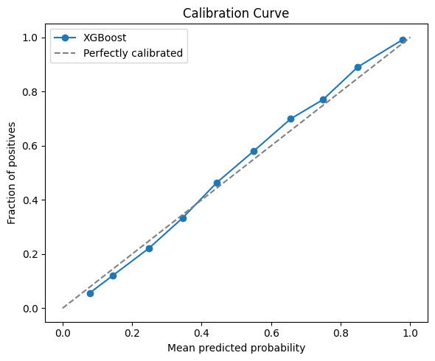
Fig. 5: Calibration curve

This figure represents a calibration curve that contrasts the actual fraction of positive cases observed with the predicted probabilities from your XGBoost model. The model's probability estimates are more accurate the closer the curve is to the diagonal dashed line, which indicates perfect calibration. The plotted line in this instance closely resembles the diagonal, suggesting that the probabilities predicted by your model are appropriately calibrated and represent the actual probability of high cholesterol in the data.

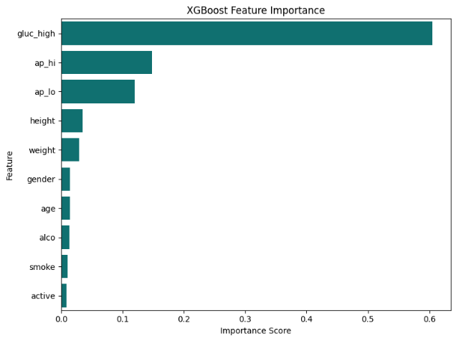
Fig. 6: XGBoost feature importance

The XGBoost model's feature importance scores for predicting the risk of high cholesterol are displayed in this bar graph. With a significantly higher importance score than the others, the feature "gluc_high" stands out as the most significant variable. While characteristics like height, weight, gender, age, alcohol use, smoking status, and physical activity play smaller roles, blood pressure measurements (also known as "ap_hi" and "ap_lo") also make a significant contribution. All things considered, the graph indicates which clinical variables most influence the model's predictions, enabling focused interventions and additional model improvement.

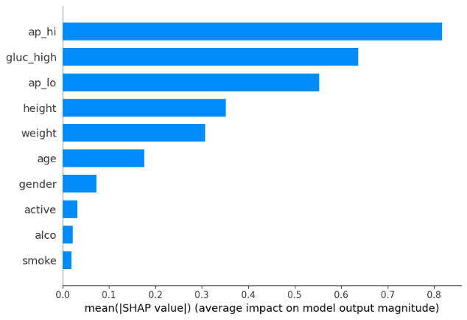

Fig. 7: bar graph representation

The average SHAP (SHapley Additive exPlanations) values for each feature in your model are displayed in this graph. These values indicate how much each feature contributes overall to the risk of high cholesterol. The influence on the model's output increases with the mean SHAP value. The most significant characteristics in this case are the systolic blood pressure (ap_hi), glucose status (gluc_high), and diastolic blood pressure (ap_lo); smoking and alcohol use have a significantly smaller impact. By showing which health indicators have the biggest impact on your model's predictions, this visualization aids in model interpretation.
- CONCLUSION AND FUTURE WORK
The XGBoost algorithm-powered Cholesterol Risk Net model effectively exhibits strong predictive performance in identifying people who are at high risk of having elevated cholesterol. With an accuracy of 84.1% and an AUC of 0.91, the pipeline demonstrated strong discriminatory power and outstanding classification capability. A model that is accurate and clinically interpretable was produced by integrating SMOTE for data balancing, meticulous feature engineering, and rigorous evaluation. Additional insights into the most important health characteristics influencing cholesterol risk were obtained through feature importance analysis. These findings highlight the usefulness of cutting-edge machine learning techniques for population health screening and clinical risk stratification.

To guarantee the model's generalizability and clinical reliability, future work for Cholesterol Risk Net will concentrate on validating it using external datasets from various populations. Prediction accuracy and interpretability may be further increased by expanding the feature set by adding more clinical, genetic, and lifestyle factors. Healthcare practitioners will find the model more transparent and reliable if explainable AI techniques like SHAP or LIME are used. We'll also look into longitudinal modelling to forecast future cardiovascular events linked to cholesterol over time. Lastly, in order to have a practical impact, the model must be translated into clinical decision support tools that can be used and integrated into healthcare workflows. By taking these steps, Cholesterol Risk Net hopes to become more widely used and contribute to more individualized preventive cardiology.

REFERENCES
- Chawla, N.V., Bowyer, K.W., Hall, L.O., & Kegelmeyer, W.P. (2002). SMOTE: Synthetic Minority Over-sampling Technique. Journal of Artificial Intelligence Research, 16, 321–357.
- Chen, T., & Guestrin, C. (2016). XGBoost: A scalable tree boosting system. Proceedings of the 22nd ACM SIGKDD International Conference on Knowledge Discovery and Data Mining, 785–794.
- Johnson, K.W., et al. (2018). Artificial Intelligence in Cardiology. Journal of the American College of Cardiology, 71(23), 2668–2679.
- Goldstein, B.A., Navar, A.M., Pencina, M.J., & Ioannidis, J.P.A. (2017). Opportunities and challenges in developing risk prediction models with electronic health records data: a systematic review. Journal of the American Medical Informatics Association, 24(1), 198–208.
- Lundberg, S.M., & Lee, S. (2017). A unified approach to interpreting model predictions. Advances in Neural Information Processing Systems, 30.
- Wei, W., Lu, Z., Tang, Y., & Zheng, W. (2022). Applications of SMOTE in Cardiovascular Disease Prediction: A Review. Frontiers in Cardiovascular Medicine, 9, 774935.
- Kaur, H., et al. (2021). AI-driven prediction of cardiovascular risk and events using multi-variable data. Biology Direct, 16(9), 1–15.
- Liu, T., Krentz, A., Lu, L., & Curcin, V. (2025). Machine learning based prediction models for cardiovascular disease risk using electronic health records data: systematic review and meta-analysis. European Heart Journal - Digital Health, 6(1), 7–22.
- Gnanavelu, A. (2025). Cardiovascular Disease Prediction Using Machine Learning. Journal of Young Pharmacists, 17(1), 226-233. DOI:10.5530/jyp.20251231
- Fazakis, N. (2023). Long-term Cholesterol Risk Prediction using Machine Learning. Scitepress.
- El-Sofany, H., et al. (2024). A proposed technique for predicting heart disease using feature selection strategies and machine learning. Scientific Reports, 14, 12345.
- Ahmad, A.A. (2023). Prediction of Heart Disease Based on Machine Learning. IEEE Access.
- Pathan, M. S., et al. (2022). Analyzing the impact of feature selection on the accuracy of heart disease prediction. Computer Methods and Programs in Biomedicine, 210, 106412.
- Ponce-Bobadilla, A.V., et al. (2024). Practical guide to SHAP analysis: Explaining supervised machine learning in healthcare. Wiley Interdisciplinary Reviews: Data Mining and Knowledge Discovery.
- Biondi-Zoccai, G., et al. (2025). Artificial Intelligence in Cardiology: General Perspectives and Future Directions. Journal of Cardiovascular Medicine.
- Meng, J.B., et al. (2025). Machine learning-based prediction of LDL cholesterol. Journal of Lipid Research.
- Elias, P., et al. (2024). Artificial Intelligence for Cardiovascular Care—Part 1. Journal of the American College of Cardiology, 83(24), 2920-2934.
- Sianga, B.E., et al. (2025). Predicting the prevalence of cardiovascular diseases using machine learning. Scientific Reports.
- Alharbi, Y. (2024). Artificial intelligence in cardiology: present state and future challenges. Computers in Biology and Medicine, 150, 106034.
- PMC (2023). Improving cardiovascular risk prediction through machine learning-based models. PMC10802828.
- ACM (2023). An XGBoost risk prediction model of cardiovascular and cerebrovascular diseases. ACM Digital Library.
- PubMed (2023). XGBoost-Based Simple Three-Item Model Accurately Predicts Cardiometabolic Risk. PMC10000880.
- Annals of Medical Research (2023). Machine learning-based forecasting of coronary artery disease.
- ScienceDirect (2025). Predicting the prevalence of cardiovascular diseases using machine learning.
- Frontiers in Medicine (2023). Cardiovascular diseases prediction by machine learning: A comprehensive review. Front Med

